OFFICIAL COORDINATION REQUEST FOR NON-ROUTINE OPERATIONS AND MAINTENANCE

COORDINATION TITLE- 14TDA05 EFL AWS Boat Restricted Zone flows
COORDINATION DATE- April 21, 2014
PROJECT- The Dalles Lock and Dam
RESPONSE DATE- May FPOM meeting.

Description of the problem- Preparation for construction of the East Fishladder Auxiliary Water Supply backup system requires surveying flows in forebay near field where the dive work will be conducted.

In order to provide accurate flow measurements, a boat with ADCP equipment will be required to survey transects within a 200’ by 300’ area directly in front of where the hole will be bored through the dam. Surveys will be required during flows most representative of when the work will be occurring. This will require an operating boat to pass within the Fish Passage Plan restricted 100’ boundary of the fishway exit. A safety boat will be used but can remain outside the 100’ limit. Refer to attached PDF for site location map. It will also require alteration to the turbine unit operation priority in the Fish Passage Plan.

The following are the 2 data sets proposed and estimated time within 100’ of the exit;

Survey #1) June: 2 days, 4-6 hrs/day, 2 different powerhouse operations, higher flow
* Get a baseline and one operational change at a medium to high flow, informing the velocity magnitudes and variability in the construction environment upstream.
* 1st-day Normal powerhouse operations for 4-6 hours for a survey boat taking ADCP measurements along lines shown in attached map.
* 2nd day West loaded powerhouse operations for 4-6 hours of a survey boat taking ADCP measurements along same lines shown in attached map.
* Anticipating ~ 10-20 minutes per survey line for each of the 11 lines; and 10-20 minutes of boat on each of 7 stationary locations (approximately 2-4 stationary points within 100 ft from ladder exit, others further away). Approximately 1- 2.5 hrs total boat time within the 100 ft boundary.
* Spill will not be impacted by this operation.

Survey #2) August or November: 3 days, 4-6 hrs/day, 3 different powerhouse operations, lower flow

* Get a baseline and two operational changes at a lower flow, informing the velocity magnitudes and variability in the construction environment.
* 1st-day Normal powerhouse operations for 4-6 hours for a survey boat taking ADCP measurements along lines shown in attached map.
* 2nd day West loaded powerhouse operations for 4-6 hours of a survey boat taking ADCP measurements along same lines shown in attached map.
* 3rd day East loaded powerhouse operations for 4-6 hours of a survey boat taking ADCP measurements along same lines shown in attached map.
* Anticipating ~ 10-20 minutes per survey line for each of the 11 lines; and 10-20 minutes of boat on single point for each of the 7 stationary locations (approximately 2-4 stationary points within 100 ft from ladder exit, others further away). Approximately 1- 2.5 hrs total boat time within the 100 ft boundary.
* Spill will not be impacted by this operation.

During the survey #2, the 3rd day will require a change to unit priority operation that is required by the Fish Passage Plan. Per recommendation by Fenton Khan, prior PNNL Battelle researcher, an additional sluicegate (gate18-2) will be opened at unit 18 and one sluicegate will be closed at unit 1 (gate 1-3) to accommodate east powerhouse loading. Additionally, work will be done mid day to when juvenile passage is lowest.

Type of outage required- West loading unit operation priority.

Impact on facility operation- None

Length of time for work- Two surveys, 1st survey=2 days; 2nd survey=3 days.

Duration of impacts- Approximately 1-2.5 hrs total boat time within 100’ of exit for each survey. Four to six hours for east loading of powerhouse per 2nd survey.

Expected impacts on fish passage-
Downstream migrants- Minimal impact if August, due to low subyearling passage and adjustment of sluiceway open gate operation maximize sluiceway passage at the east end of the powerhouse. Negligible if done in November, due to end of juvenile passage season.

Upstream migrants- This work will occur within the 100’ buffer of the east fishladder exit required by the FPP. Below is a graph showing the 10 year average for adult passage at TDA. The bulk of the fish run may be avoided if the June surveys are scheduled for early in the month and November is chosen for the later survey.

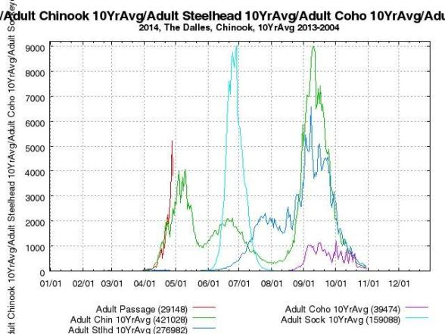

Bull Trout- Unknown. Occurrence in Action Area is highly unlikely. Of the five distinct population segments (DPS) of bull trout listed as threatened by the USFWS, the Columbia River DPS is the only one that is likely to occur in the vicinity of the proposed project. Historically, bull trout of the Columbia River DPS likely ranged through much of the Columbia River Basin with spawning and rearing occurring in the coldest creeks, often at higher elevations. Presently, bull trout of the Columbia River DPS are distributed in a more fragmented pattern throughout the Columbia River Basin with fewer adult migratory fish and fewer, more compressed spawning reaches than historically occurred.

WDFW and Corps personnel provided a list of anecdotal sightings/captures of bull trout in the mainstem Columbia River. From 2000 through 2012 there were eleven bull trout reported. Three were downstream of Bonneville Dam, with two at the mouth of Hamilton Creek (RM 143) and one in 2005 at the Bonneville Dam Smolt Monitoring Facility (RM 144). Upstream of the dam, one bull trout was found at Cascade Locks (RM 149), two at Drano Lake (RM 162), two at the mouth of the Klickitat River (RM 180.5), one in 2002 at the John Day Dam Smolt Monitoring Facility (RM 215), and one sighting at Dog Creek Falls by a reputable WDFW creel sampler who observed 18- to 24-inch cuts or dollies working old redds below the splash pool over the course of two weeks. Fish passage data from the Bonneville Dam fish ladders (Corps, unpublished) show only three sightings of bull trout moving through the fish ladders for 2000 through 2011 during the fish counting season (April 1 through October 31). These sightings occurred between May 30, 2009 and June 2, 2009 and were reported as ‘12-inch bull trout moving upstream’ through the count window on each occasion.

Lamprey- No expected impacts. This work will be completed outside the normal lamprey passage window.

Comments from others-
Final results-
Please email or call with questions or concerns.
Thank you,
Jon Rerecich
Fish Passage Team
503-808-4779
Jonathan.g.rerecich@usace.army.mil

Tammy Mackey
NWP Operations Division Fishery Section
503-961-5733
Tammy.m.mackey@usace.army.mil

